BOOK ANNOUNCEMENT

Coming mid-October 2013 from The Institute for Perception…

Tools and Applications of Sensory and Consumer Science

48 Technical Report Scenarios Based on Real-life Problems
This book organizes and compiles our most significant and useful technical reports from the last 15 years. With a new index and updated tables, this book is a must-have tool for professionals in product testing, consumer research, and claims support. Readers will easily relate to the issues and the corresponding resolutions that are discussed in each concise, two-page scenario. What makes this book unique is its story-telling style based on scenarios that can take place within any consumer products company.
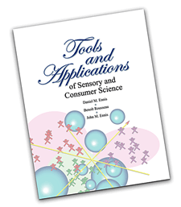
Drs. Daniel Ennis, Benoît Rousseau and John Ennis use their combined expertise to guide readers through problems in areas such as:
- Difference Tests
- Rating and Rankings
- Claims Support
- Drivers of Liking® and Landscape Segmentation Analysis® (LSA)
- Optimizing Product Portfolios
- Probabilistic Multidimensional Scaling
- Combinatorial Tools
The technical content behind each scenario has been kept to a minimum so that ideas can be absorbed easily, but there is plenty of opportunity to pursue each account in more detail. Examples range from dairy products to beverages and fragrance products and are designed to appeal to a broad audience in the product research field. 27 tables for product testing methods have been included so the reader can interpret results from discrimination methodologies such as the tetrad test, the triangle test, the same-different method, the duo-trio test, replicated testing, and others.
163 pages, $95, plus shipping and 5.3% VA sales tax, where applicable.
To order copies of this book (will ship in mid-October) please call (804) 675-2980 or visit www.ifpress.com

